Distributed and Operating Systems

2024

Lab 1: Bazar.com: A Multi-tier Online Book Store

Dr.Samer Al-Arandi

Omar Ratrout

11941267

Front end : redirect user request to back end (catalog and order) services using HTTP REST calls.

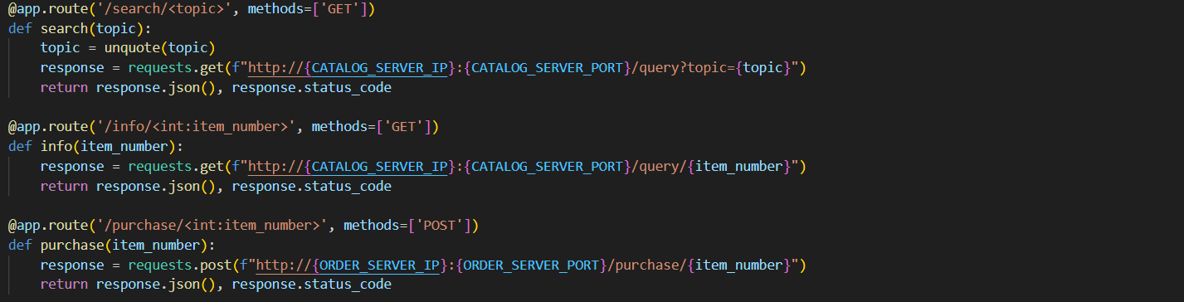

When a search call received forward the the http call to catalog and apply query to get data from sqlite data base.



Or Item

when use ask for a purchase operation :

* Front end redirect the request to order service
* Apply a query to get the data from catalog data base to check if the availability of the book if not book not available in catalog data base return Book not found 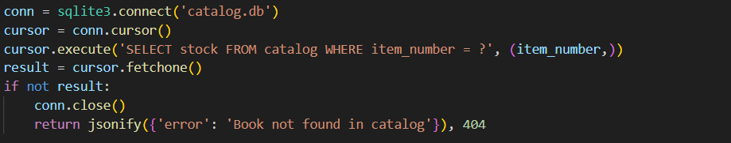
* If it is exists but out of stock 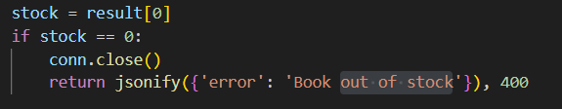
* Else the operation will be completed and the the stock amount will be Decrement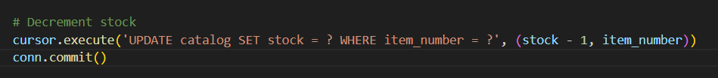
* Finally, Record the purchase to order data base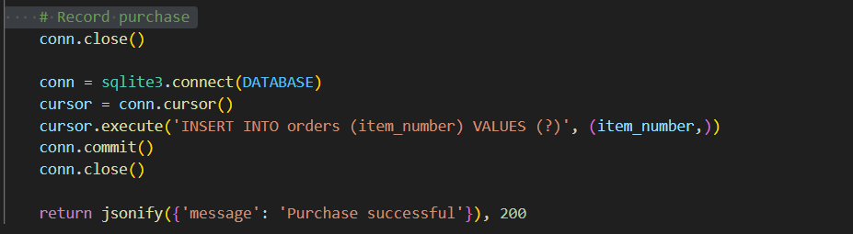

Result